*Florida International University*

*School of Computing and Information Sciences*

CEN 5011- Advanced Software Engineering

Feature Document

User Story #1140

# **Add Faculties registration page to the website**

**Team Member:**

Shefali Nakum

**Product Owner(s)**:

Masoud Sadjadi

**Mentor(s)**:

Mohsen Taheri

**Instructor**: Masoud Sadjadi

# 

# 

# **User Story - Add Faculties registration page to the website**

● As a Website Admin(Pi/CoPi), I would like to view the list of faculties registration requests.

## **Use Case**

**Use Case ID:** (VIP-1140)

**Details:** Add Faculties registration page to the website

**Actor:** Admin(Pi/CoPi)

**Pre-conditions:**

1. Admin(Pi/CoPi) has navigated to the VIP website.

2. Admin(Pi/CoPi) is able to login.

**Description:**

1. Admin(Pi/CoPi) has to click on Prospective Students and click on the “REVIEW FACULTY REGISTRATIONS” tab.

2. Admin(Pi/CoPi) should find the faculty registration requests which is similar to the student’s application requests page

**Post-conditions:**

1. Admin(Pi/CoPi) should be able to Approve, Reject, Undo or Delete the faculty registration request.

**Alternative Courses of Action:**

N/A

**Exceptions:**

N/A

**Related Uses Case:**

N/A

**Use Case Diagram**

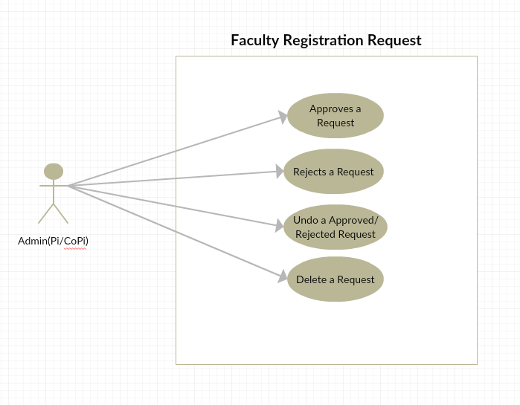

**Sequence Diagram**

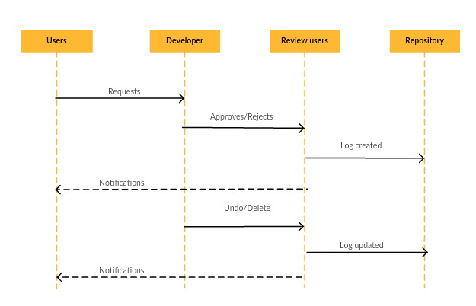

**Class Diagram**

N/A

**Unit & Integration Tests:**

## **● Test Case 1(Sunny Day)** ○ Purpose: Test that the REVIEW FACULTY REGISTRATIONS under PROSPECTIVE STUDENTS is showing the registration requests.

## ○ Precondition: Pi/CoPi has reached the VIP site and reach the REVIEW FACULTY REGISTRATIONS page under PROSPECTIVE STUDENTS tab.

## ○ Input: Pi/CoPi can approve or reject a faculty registration request. He can also undo an Approved/Rejected request and can even delete the registration.

## ○ Expected Result: Pi/CoPi can be able to view the page without errors and can be able to perform various operations like approve or reject a faculty registration request. Also can undo an Approved/Rejected request and can even delete the registration.

## ○ Actual Result: Pi/CoPi has able to view the page without errors and is able to perform various operations like approve or reject a faculty registration request. Also he/she able to undo an Approved/Rejected request and can even delete the registration. ○ Status: SUCCESS **Visual User Guide**

